Ping [www.google.com](http://www.google.com)

Ip a

apt update

apt install bind9 bind9-utils

ufw allow bind9

**Configuración de archivos y zonas**

Abrimos Firefox y buscamos jcastaneda.com. Configurar un servidor DNS Bind en Ubuntu Server

nano /etc/bind/named.conf.options Copiamos y pegamos todo este textote

acl internals {

127.0.0.1;

192.168.1.0/24;

};

options {

directory "/var/cache/bind";

recursion yes; # permitir consultas recursivas

allow-recursion { internals; }; # definimos desde que rango de Ips pueden realizar consultas

listen-on port 53 { 192.168.1.100; }; # definimos ip privada - solo para red interna

allow-transfer { none; }; # desabilitamos la transferencia de zonas por default

// If there is a firewall between you and nameservers you want

// to talk to, you may need to fix the firewall to allow multiple

// ports to talk. See http://www.kb.cert.org/vuls/id/800113

// If your ISP provided one or more IP addresses for stable

// nameservers, you probably want to use them as forwarders.

// Uncomment the following block, and insert the addresses replacing

// the all-0's placeholder.

forwarders {

8.8.8.8;

8.8.4.4;

};

//========================================================================

// If BIND logs error messages about the root key being expired,

// you will need to update your keys. See https://www.isc.org/bind-keys

//========================================================================

dnssec-validation auto;

//listen-on-v6 { any; };

};

nano /etc/bind/named.conf.local

* Crearemos nuestro dominio, ejemplo: dominiodns.com y pondremos IPs

//

// Do any local configuration here

//

zone "dominiodns.com" {

type master;

file "/etc/bind/zones/db.dominiodns.com";

allow-transfer { internals; };

};

zone "[IP server invertida sin ultimo octeto].in-addr.arpa" {

type master;

file "/etc/bind/zones/db.[IP server sin último octeto]";

allow-transfer { internals; };

};

// Consider adding the 1918 zones here, if they are not used in your

// organization

include "/etc/bind/zones.rfc1918";

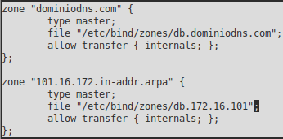

mkdir /etc//bind/zones

nano /etc/bind/zones/db.dominiodns.com. Pondremos nuestro dominio e IPs

;

; BIND data file for local loopback interface

;

$TTL 604800

@ IN SOA ns1.[dominiodns.com]. root.[dominiodns.com]. (

20210222mml.

; Serial

12h ; Refresh

15m ; Retry

3w ; Expire

2h ) ; Negative Cache TTL

;

@ IN NS ns1.[dominiodns.com].

@ IN A [IP Cliente]

ns1 IN A [IP Servidor]

www IN CNAME [dominiodns.com].

tester IN A [IP Servidor]

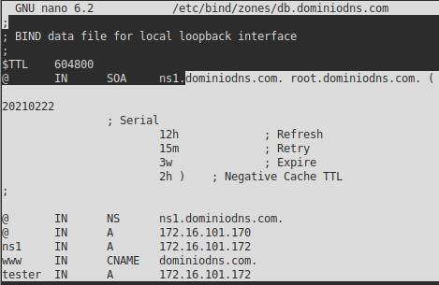

nano /etc/bind/zones/db.[IP Servidor]

;

; BIND reverse data file for local loopback interface

;

$TTL 1d ;

@ IN SOA ns1.[dominiodns.com] root.[dominiodns.com]. (

20210222 ; Serial

12h ; Refresh

15m ; Retry

3w ; Expire

2h ) ; Negative Cache TTL

;

@ IN NS ns1.[dominiodns.com].

110 IN PTR tester.[dominiodns.com].

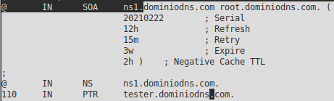

named-checkconf

named-checkzone [dominiodns.com] /etc/bind/zones/db.[dominiodns.com]

named-checkzone db.[IP Servidor].in-addr.arpa /etc/bind/zones/db.[IP Servidor]

systemctl restart bind9

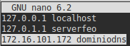**Instalación de apache**

nano /etc/hosts

[IP Servidor] [dominiodns]

apt install apache2 -y

ufw allow ‘apache’

* Puede decir “ok” o “Skipping adding existing rule”. Ambas están bien

systemctl status apache2

* Si da algún error ah000588 poner:
* Nano /etc/apache2/apache2.conf
  + Al final poner: SeverName 127.0.0.1 Si tampoco, reemplazar la IP por “localhost”

systemctl restart apache2

systemctl status apache2

**Hacer ping**

ping [dominiodns.com]

ping [IP Servidor]

ufw status

* Puede decir “Status: inactive” pero igual jala.

a2dissite 000-default.conf

systemctl reload apache2

systemctl restart apache2

**Creación del archivo index.html o php**

nano /etc/apache2/sites-available/tester.[dominiodns].com.conf

* Pegamos esta cosa:

<VirtualHost *:80>

ServerAdmin webmaster@localhost

ServerName tester.[dominiodns].com

DocumentRoot /var/www/tester.[dominiodns].com

ErrorLog ${APACHE_LOG_DIR}/error.log

CustomLog ${APACHE_LOG_DIR}/access.log combined

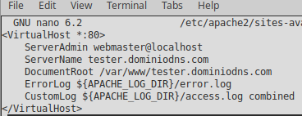</VirtualHost>

mkdir /var/www/tester.[dominiodns].com

nano /var/www/tester.[dominiodns.com]/index.html ó php

* Pondremos lo que queramos

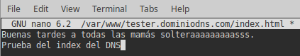

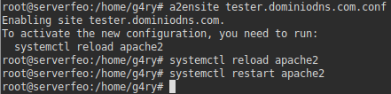A2ensite tester.[dominiodns].com.conf

Systemctl reload apache2

Systemctl restart apache2

Si probamos en un navegador la IP del servidor, ya se verá el index que acabamos de hacer. Nota: aquí se muestra otra IP por ser otro intento pero el procedimiento es el mismo.

